# Sheet-Cell – README

**SheetCell** is an advanced spreadsheet engine designed for performing calculations, organizing, and managing data dynamically. The system simulates the functionality of a spreadsheet like Excel or Google Sheets, enabling users to perform advanced calculations, share, and update data in real-time. The system also offers unique features like version management, recalculating values, supporting custom functions, and more.

Table of Contents

General Description

Helper Functions

Running the Project

System guide

## General Description

The system is divided into four main modules, each responsible for a different part of the application:

1. **Engine Module:**
   * This module contains all the system’s logic, including value calculations, cell management, version control, and synchronization between different cells. The engine performs requested calculations, manages recalculations, and provides the necessary data to the UI module.
2. **UI Module:**
   * The UI module is responsible for displaying the data to the user through a graphical interface built with JavaFX. The interface allows the user to input data, execute functions, view results, and interact with the system in a user-friendly manner.
3. **DTO Module (Data Transfer Objects):**
   * This module acts as a bridge for transferring data between the engine and the UI. It is responsible for organizing and structuring the data in a way that is easy to transmit between the different modules of the system.
4. **Server Module:**
   * The server module is responsible for handling client requests and "activating" the engine. It supports remote services, enabling multiple users to work simultaneously on the same spreadsheet while maintaining synchronization and executing calculations on the engine.

**System Implementation**

1. **Engine Module:**

* In this module, all the system's core logic is implemented. This includes managing the spreadsheet’s cells and recalculating values when a cell is modified. The engine interacts with different functions that perform calculations, including support for custom functions that allow users to execute advanced calculations.
* The spreadsheet is managed as a collection of cells, where each cell contains a value, data type, and calculated value. The engine automatically recalculates related cells when necessary.

2. **UI Module:**

* The UI module is responsible for presenting data to the user through an interactive JavaFX-based graphical interface. The interface displays the spreadsheet clearly and provides tools for user interaction, such as dragging cells, updating values, and executing calculation functions. The interface is designed to present data in an intuitive way and provides users with all the necessary tools for efficient operation.
* Additionally, the UI module receives data from the engine module and updates the display accordingly.

3. **DTO Module:**

* The DTO module serves as a data transfer layer between the engine and the UI. It is responsible for organizing the data in a way that is easily transferred and understood between the system modules. Any data that is passed from the engine to the UI or vice versa goes through the DTO module.

4**. Server Module:**

* The server module handles incoming requests from the UI or external systems and forwards them to the engine. The server is responsible for managing connections, updating data, and performing remote calculations. The module supports multi-user collaboration, so any changes made to the spreadsheet are automatically updated across all connected users.

**Key Features**

* Value Modification: Any change to a cell automatically updates its effective value and all related cells.
* Recalculation: Any change in a cell can affect other cells, and the system automatically recalculates the affected cells.
* Version Management: The system saves versions of the spreadsheet and allows the user to revert to previous versions.
* Functions: The system supports basic functions like addition, subtraction, division, and more, and allows users to define custom functions.
* Error Handling: The system detects errors such as circular references, illegal references, or references to non-existing cells.
* Additional Capabilities:
  + Cell design and styling.
  + Data filtering and sorting.
  + "WHAT-IF" analysis – dynamic value changes with immediate results.
  + Sharing spreadsheets with multiple users and collaborative editing.

## Helper Functions

The system supports defining helper functions that can be integrated into different cells. Each function is defined with a unique name and arguments, where each argument can be a number, string, Boolean value, or a reference to another function.

Function Invocation Format

The function invocation will be defined using the following structure:

**{<function name>,<arg 1>,<arg 2>,…,<arg n>}**

**Explanation of the structure:**

1. Each function is enclosed in curly braces {}.
2. function name: The unique name of the function, in uppercase only.
3. Each argument is separated by a comma (,), and there are no spaces between the commas.
4. arg i: The i-th argument that the function receives. This can be a number, string, Boolean value, or a reference to another function.
5. Invalid result: If the function cannot return a valid result, it will return the following:
   * NaN for numeric values.
   * !UNDEFINED! for string values.
   * UNKNOWN for Boolean values.
6. If the function is not valid in terms of its structure (unknown name, incorrect number of arguments), it will invalidate its value and halt the computation.
7. Any operation on a cell with an invalid value will also be considered invalid.

**Examples:**

* {PLUS, 4, 5} – Adds 4 and 5.
* {MINUS, {PLUS,4,5},{POW,2,3}} – Adds 4 and 5, then subtracts the result of 2 raised to the power of 3.

**List of Helper Functions:**

**Logical Functions:**

|  |  |  |
| --- | --- | --- |
| **#** | **Function Name** | **Description** |
| 1 | EQUAL | Compares two values |
| 2 | NOT | Boolean negation of a value |
| 3 | OR | Logical OR operation between two Boolean values |
| 4 | AND | Logical AND operation between two Boolean values |
| 5 | BIGGER | Checks if arg1 is greater than or equal to arg2 |
| 6 | LESS | Checks if arg1 is smaller than or equal to arg2 |
| 7 | IF | If-then-else Boolean function |

**Mathematical Functions:**

| **#** | **Function Name** | **Description** |
| --- | --- | --- |
| 1 | PLUS | Adds two values |
| 2 | MINUS | Subtracts two values |
| 3 | TIMES | Multiplies two values |
| 4 | DIVIDE | Divides two values (with handling for division by zero) |
| 5 | MOD | Modulo operation between two values |
| 6 | POW | Raises a value to a power |
| 7 | ABS | Returns the absolute value of a value |
| 8 | SUM | Sums values in a range |
| 9 | AVERAGE | Averages values in a range |
| 10 | PERCENT | Calculates a percentage of a value |

**String Functions:**

| # | Function Name | Description |
| --- | --- | --- |
| 1 | CONCAT | Concatenates two strings |
| 2 | SUB | Extracts a substring from a string |

**System Functions:**

| **#** | **Function Name** | **Description** |
| --- | --- | --- |
| 1 | REF | References the value of another cell |

## Running the Project

**Running the Server and Client**

**1. Running the Server:**

To run the server, navigate to the Run directory in the project and execute the server_run.bat file.

**2. Running the Client:**

To run the client, go to the Run directory, extract the client_run.zip folder, and execute the client_run.bat file inside it.

## System guide

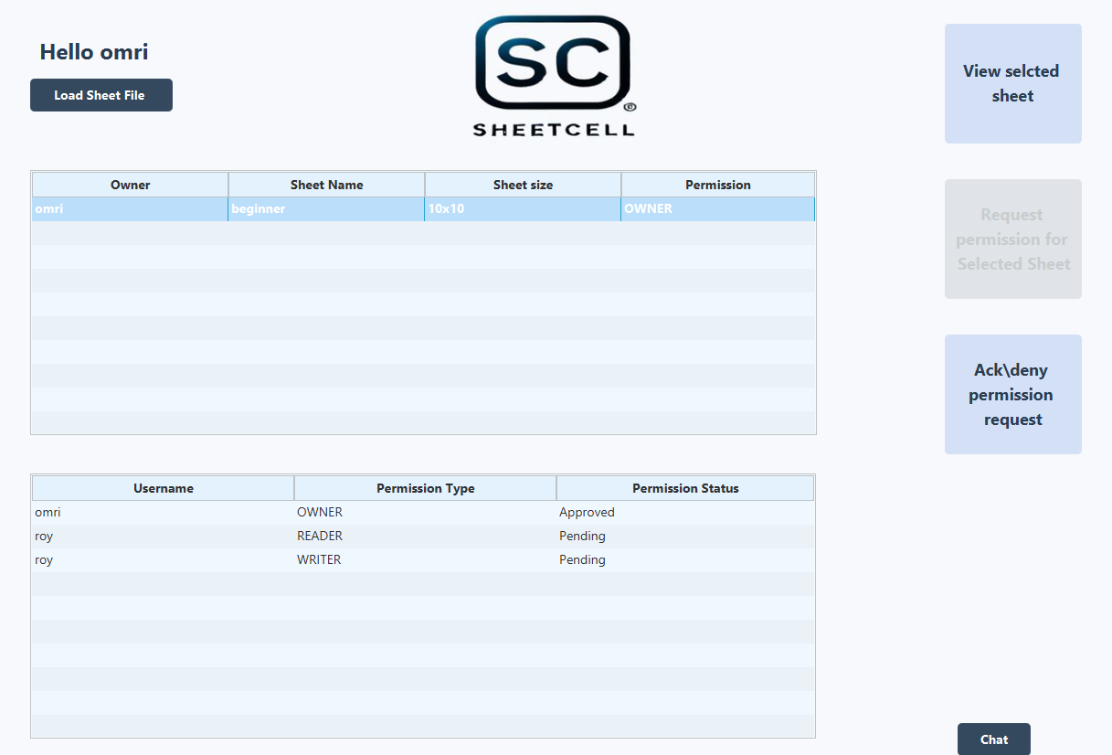

1. Load the FXML file into the system.

2. Display the selected sheet.

3. Request permission for the selected sheet.

4. Display requests for sheets owned by the user.

5. Display all sheets in the system.

6. Display all requests for the selected sheet along with their status.

7. Display the system chat.

**"Action line area":**



1. **Cell ID**: Displays the ID of the selected cell.

2. **Original Value**: Shows the original value of the selected cell.

3. **Action Line**: Allows the user to input the value they want to update in the selected cell.

4. **Update Value**: Updates the selected cell with the value entered by the user.

5. **Last Updated Cell Version**: Displays the last updated version of the selected cell.

6. **Version Selector**: Enables the user to view all versions of the sheet.

When the user selects a cell, the frame of the selected cell is highlighted in red. The cells it depends on are highlighted in blue, while the cells that depend on it are highlighted in green.

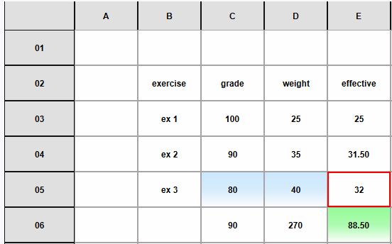

If the user clicks on a column header, all the cells in that column will be highlighted in light red, allowing the user to apply design changes to the entire column simultaneously.

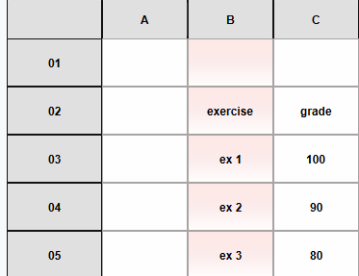

**"Style Sheet area":**

With these buttons, the user can style the selected cell or column:

* **Bottom, Center, Top, Left, Center, Right:** These buttons align the text according to their respective positions.

1. In this box, the user can set the text size.
2. In this box, the user can select the font for the text.
3. This color picker allows the user to choose the text color.
4. This color picker allows the user to choose the cell background color.

The **Reset Cell** button resets the selected cell to the default design, while the **Reset Sheet** button applies the default design to all cells in the sheet.

If the user clicks and drags the edges of the column headers or row headers, they can adjust the width or height of the respective column or row.

**"Command area":**

**Sort and Filter:**

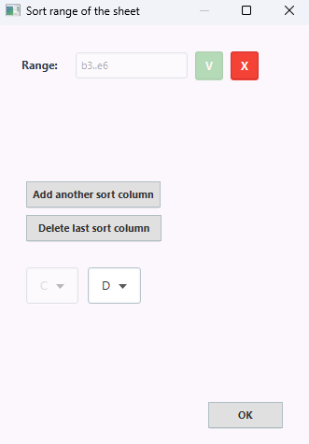

At the top of the window, the user needs to enter the range in the following format: <top left cell id>..<bottom right cell id>. After this, the user selects the first column, and then additional columns can be added for sorting or filtering based on them.

**Create a Graph:**

At the top of the window, the user selects the type of graph. Then, the user specifies the range for the x-axis and the y-axis. They can also assign titles to each axis if desired.

1. In this choice box, the user can choose to either enter a custom range or select a predefined range from the system.

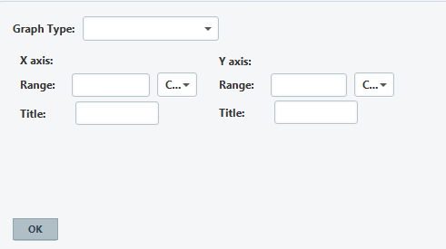

**Custom Formula:**

The user can select the desired function from the list. If the user prefers to input a custom value, they can select "Custom" from the Choice Box.

"**Range area":**

When the user selects a range, all cells within that range are highlighted in blue.

**Add range:**

The user assigns a name to the range and then inputs the range in the following format: <top left cell ID>..<bottom right cell ID>.

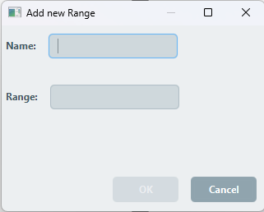

**Delete Range:**

After the user selects "Delete Range," they need to choose the range they want to delete and then click on "Submit Delete" to confirm, or "Cancel" to discard the action.

